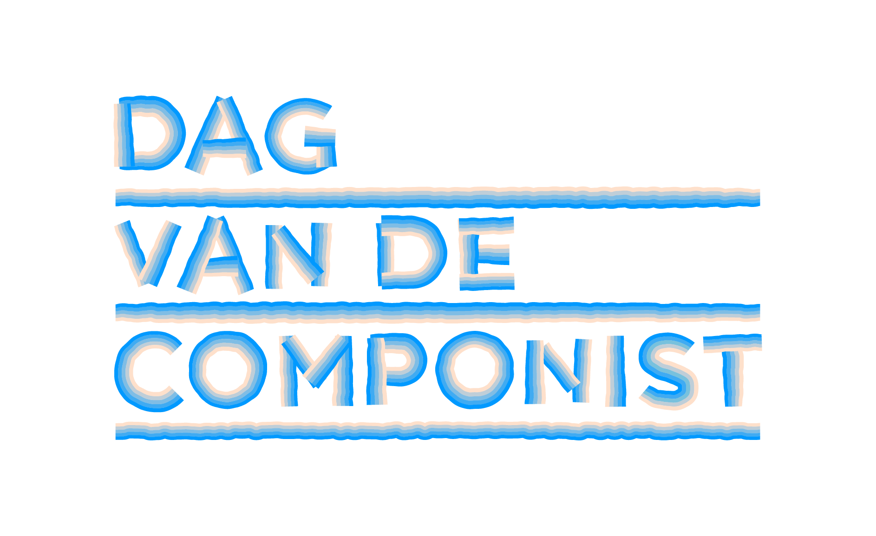
Persbericht, 12 juni 2025

Opening of Composer’s Day 2025 Moved to Grand Café Restaurant 1e Klas at Amsterdam Central Station, 9:00 AM on Saturday, June 21, 2025
The opening concert of Composer’s Day 2025 will take place in a unique venue: the beautifully restored former station waiting rooms designed by architect Cuypers, now home to Grand Café Restaurant 1e Klas at Amsterdam Central Station, platform 2B. On Saturday, June 21, 2025, starting at 9:00 AM, this venue will host the first performance in a nationwide day of new music.
● Sat 21 June 2025, starts at 09:00 (doors open at 08:30)
● Grand Café Restaurant 1e Klas, platform 2B, Amsterdam Central Station
● Free admission
This location also serves as the departure point for the New Music NOW Express, a special train that stops in several cities during Composer’s Day. Composer’s Day is an annual celebration of the importance, value, and joy of contemporary composers active in the Netherlands. Around June 21, this national event takes place in 20 cities with over 200 concerts — not only in concert halls, but also at train stations and even on the train itself!
Moved Due to Amsterdam 750 Years
Due to expected crowds around the celebration of Amsterdam’s 750th anniversary, the city did not grant permission for the originally planned concert on the IJ-Boulevard. Fortunately, an equally special alternative location was found on short notice. This new venue remains within walking distance of the original location and is directly connected to the New Music NOW train project.
Station Concert Program – Amsterdam Central Station
Starting at 9:00 AM, visitors can enjoy a morning coffee concert featuring top musicians and composers from Amsterdam. The program includes:
● The concert opens with the Maat Saxophone Quartet, traveling all day as the festival ensemble.
● City Composer Kate Moore composed Growing Against the Wind especially for Amsterdam's 750th anniversary, based on the diaries of Etty Hillesum. The piece will be performed by the VU Chamber Choir, conducted by Krista Audere.
● Fuensanta, a versatile composer, vocalist, and double bassist from Mexico, performs with renowned alto saxophonist and composer Ben van Gelder. Together they blend poetry, jazz, and imagination into a stirring live performance.
● Martin Fondse (former Composer Laureate of the Netherlands) and Femi Dawkins (interdisciplinary artist and performer) present an energetic and thought-provoking performance filled with text, music, and surprise.
After the concert, the New Music NOW Express departs from platform 2B at 10:05 AM, heading to Arnhem, Utrecht, Rotterdam, The Hague, and back to Utrecht.
Info & tickets: Composer’s Day – New Music NOW

Further Composer’s Day Programming – Amsterdam
Sat 14 June – Concertgebouw
● 13:40 – Concertgebouw, Mirror Hall: VU Chamber Choir performs the new city song Growing Against the Wind by Kate Moore, with an interview prior to the ZaterdagMatinee: Frederike Berntsen in conversation with Kate Moore
● 14:15 – ZaterdagMatinee, Concertgebouw Main Hall: Kate Moore, Ensemble Resonanz, Abel Selaocoe – When We Were Trees
● 14:15 – Concertgebouw, Small Hall: Arjan Linker – Echoes of Our Planet
Sun 15 June – Amsterdam
● 14:15 – Orgelpark: Gerard Beljon – Dream of Peace / Somnium al Salaam
● 16:00 – Gamelan House: Sinta Wullur, Maarten Bauer – Global Gongs Lab
Mon 16 June – Amsterdam
● 16:00 – Walloon Church: Hinse Mutter, Hans Blok Ensemble Ratel
● 19:00 – WeLiveHere: Hinse Mutter, Hans Blok Ensemble Ratel
Fri 20 June – Splendor Amsterdam
● 20:00 – Night of the Composer: Julija Hartig, Akim Moisenkov, Luke Deane, Toets des Tijds, Grond Bajesdorp, Plantagedok
Sat 21 June – Various locations
● 05:19 – Pension Homeland, Marineterrein: Kate Moore, Herz Ensemble – Sunrise Concert
● 08:00 – Oosterpark: Evelien van den Broek – Avian Humanoids
● 09:00 – Grand Café Restaurant 1e Klas, Amsterdam Central: Maat Saxophone Quartet, Martin Fondse, Femi Dawkins, VU Chamber Choir, Kate Moore, Fuensanta, Ben van Gelder – Composer’s Day Station Concert
● 14:15 – Concertgebouw, Main Hall: Joël Bons, Atlas Ensemble – New work (ZaterdagMatinee)
● 20:00 – Central Market Hall: Tilen Lebar, Dirk Hooglandt, Pergolesi Ensemble – The Eternal Now
● 20:30 – Bimhuis: Maripepa Contreras, Antonio Moreno, Arin Keshishi – Sonic Bridges
For the full program, see: www.newmusicnow.nl/dagvandecomponist

Not for publication – for press inquiries, please contact:
- Marjolein van Ruiten – PR@marjoleinvanruiten.com | 06-200 62 844
- Esther Gottschalk – esther@newmusicnow.nl | 06-27 027 547
- Trailers – Dag van de Componist in 20 steden – New Music NOW; New Music NOW Express; Slotconcert Dag van de Componist en uitreiking Matthijs Vermeulenprijs 2025
- Persfoto’s & perskit beschikbaar via Perskit - New Music NOW
====
Presse Release Composer’s Day, 12 juni 2025

Composer’s Day Turns the Netherlands into One Big Music Station on June 21

On and around Saturday, June 21, 2025, the fourth edition of Composer's Day will take place. Composer's Day transforms the Netherlands into one big music station. During this national festival, more than twenty participating cities will put their composers in the spotlight with a variety of activities, such as concerts, workshops, and lectures. City composers will create a new City Song for their city. The public can travel from station to station with the New Music NOW Express. Live performances will take place in the train's carriages and at the stations. Radio station NPO Klassiek and the online music platform newmusicnow.nl will devote plenty of attention to Dutch new music art. Composer's Day is an initiative of New Music NOW and is unique in Europe.

With Composer's Day, the Netherlands celebrates the importance, value, and joy of new music. Composers active here and now in our country deserve to be heard much more often. Therefore, the festival highlights them in all their versatility. They are visibly present and approachable to the public, giving workshops and lectures, curating programs, and offering a "peek into their world." And, of course, their music is heard. Not only in concert halls but also on the streets, at radio and train stations, and on the train itself. With Composer's Day, New Music NOW aims to spark nothing less than a movement because creation and curiosity belong at the heart of musical life.

Composer's Day takes place on and around Saturday, June 21, 2025, and consists of the following elements:

Multi-day program with over 200 composers in more than 20 cities
Numerous music organizations and composer collectives work together as the New Music NOW Network. They will collaborate with composers from their cities and neighborhoods, presenting more than 200 activities across 20+ cities. Participating cities include Amsterdam, Arnhem, Utrecht, Rotterdam, The Hague, Den Bosch, Eindhoven, Tilburg, Heerlen, Maastricht, Almere, Amersfoort, Zwolle, and Groningen. Network partners for Composer's Day include TivoliVredenburg, Concertgebouworkest, Amare, de Doelen, Musis & Stadstheater Arnhem, November Music, Gaudeamus, Intro in Situ Heerlen/Maastricht, De Link Tilburg, Orkest De Ereprijs, and many choirs, ensembles, music associations, conservatories, music schools, artist collectives, publishers, and producers.

New Music NOW Express
The specially chartered bright red music train, the New Music NOW Express, connects the national program and draws a trail of new music across the country. The train stops at five stations: Amsterdam, Arnhem, Utrecht, Rotterdam, The Hague, and returns to Utrecht. On board, there will be plenty of live performances by emerging and renowned composers; the audience sits side by side with musicians and composers in the train carriages.

Newly appointed City Composers and Newly composed City Songs
In the five cities visited by the Express, special City Composers have been appointed. They will compose a new City Song, premiered during the festive Station Concerts, with participation from local choirs, ensembles, conservatories, and other organizations. The City Composers are:
- Kate Moore (Amsterdam)
- Andries van Rossem (Arnhem)
- Saskia Venegas (Rotterdam)
- Maxim Shalygin (The Hague)
- Nawras Altaky (Utrecht)
Additionally, Angela de Weijer (Heerlen), Nicoline Soeter (Tilburg), and Hans Leenders (Maastricht) serve as City Composers for a two-year term.

Station Concerts Along the New Music NOW Express Route
At 05:19 AM, on the longest day of the year, Kate Moore and her Herz Ensemble will open with a sunrise song cycle based on Cantico del Sole at the Marineterrein near Pension Homeland in Amsterdam. This is followed by a communal breakfast and a procession to Amsterdam Central Station for the Station Concert.
09:00 AM – Amsterdam Central Station (Platform 2B):
The City Song "Growing Against the Wind," composed by Kate Moore for the city’s 750th anniversary, will be performed by the VU Chamber Choir. The dynamic Maat Saxophone Quartet is the festival ensemble. Rising star Fuensanta (composer/singer/double bassist) will perform alongside alto saxophonist Ben van Gelder. Martin Fondse and Femi Dawkins will energize the crowd with Your Favorite Music Station. Afterward, the audience can either board the New Music NOW Express or attend other events in the city.
11:30 AM – Arnhem Central Station:
City Composer Andries van Rossem hosts a collective happening with students and alumni of ArtEZ. Composer Tobias Wentink contributes a new City Song, and percussion group performances curated by Dolf de Kinkelder feature prominently, with young talent presented throughout the city.
1:00 – 2:00 PM – Utrecht Central Station (Jaarbeurs side):
A spectacular concert by the 70-member NS Orchestra (Dutch Railways’ in-house ensemble) featuring works by Dutch composers such as Leon Vliex, Eric Swiggers, Emile Stoffels, and Jörgen IJsendorn. Events continue at Museum Speelklok and Sounds Like Juggling under the station’s glass dome.
2:25 – 3:30 PM – Rotterdam Central Station (Rotjekoor Festival):
Belgian-Basque composer Saskia Venegas presents Maasstad, an ode to the city, its harbor, and its people, performed by local choirs, Maat Quartet, and the Basque percussion instrument txalaparta. A musical city route follows, curated by Venegas, including a premiere on June 20 in the Paradijskerk by the Oihua Ensemble.
4:30 PM – The Hague Central Station:
Ukrainian-Dutch composer Maxim Shalygin premieres Burlesque on the Death of a Dictator, performed by the Neo-Fanfare 9x13. The Royal Conservatoire showcases talent at both Amare and the station. The public Trap Theatre at Amare will feature performances by the New European Ensemble and others from 2:00–4:00 PM.
6:20 PM – Utrecht Central Station (glass dome):
City Composer Nawras Altaky presents A City Woven in Music, together with the Young Jazz Society Big Band, Tijn Wybenga, Kika Sprangers, and many Utrecht musicians. This co-production with Gaudeamus brings the day's music full circle.
New Stations in Eindhoven and Maastricht:
Though the Express doesn’t stop there, both cities celebrate the day with their own Station Concerts and local programming.

Closing Concert & 2025 Matthijs Vermeulen Prize Ceremony
8:15 PM – Museum Speelklok, Utrecht
An evening program for the public featuring special guests, composers, top ensembles, and a tribute to the best works of the past year.
Trevor Grahl will receive the Matthijs Vermeulen Prize 2025 for his composition Śpiewnik. Presented by Viktorien van Hulst (Director, Dutch Performing Arts Fund), the jury praised the work’s unique sound world combining memory, identity, and musical innovation—a moving and boundary-breaking piece for organ. The Vermeulen Prize is the Netherlands’ most prestigious composition award, presented biennially.
Program Highlights:
- Ensemble HIIIT performs Ma(n)chine by Zeno van den Broek—a dynamic clash between four percussionists and drum robots with powerful visuals.
- Maat Saxophone Quartet focuses on climate awareness with works by Frieda Gustavs and Ramin Amin Tafreshi.
- Nawras Altaky & friends bring messages of urgency and hope.
- Maya Fridman honors past Vermeulen Prize winners Calliope Tsoupaki and Louis Andriessen with Thin Air and La Voce.
- The spectacular AU-2-MATERIA couture music dress by designer Maartje Dijkstra and composer Beorn Lebenstedt is on display in the church.
The concert is a co-production by New Music NOW, TivoliVredenburg, and the Performing Arts Fund, held at Museum Speelklok (Buurkerk) and recorded for later broadcast.

Favorite Music Stations: Radio NPO Klassiek and New Music NOW TV
Around June 21, Radio NPO Klassiek and New Music NOW TV will focus on Composer's Day. Broadcasters NTR Klassiek, VPRO Vrije Geluiden, and Avrotros will present ten days of composer specials, previews, and live performances on national public radio.

Funding & Partners
Composer's Day 2025 is made possible by various funds and municipalities, including Buma Cultuur, the Cultural Fund, Reinbert de Leeuw Foundation, Dioraphte, Sena Performers Fund, Amsterdam Fund for the Arts, Municipality of Rotterdam, Municipality of Utrecht, Municipality of Arnhem, Berch Heemstede Fund, K.F. Hein Fund, Berch Heemstede Fund, and media partners NTR:Klassiek, VPRO Vrije Geluiden, Avrotros, Concertzender, and many network partners.

For the Composer's Day 2025 program:
https://newmusicnow.nl/dagvandecomponist/

====
Not for publication: contact for press:
Marjolein van Ruiten, PR@marjoleinvanruiten.com, 06-200 62 844
Esther Gottschalk, esther@newmusicnow.nl 06-27 027 547
Trailer Dag van de Componist – New Music Now
Persfoto’s Perskit – New Music Now

BIJLAGE

Foto Downloads Perskit – New Music Now

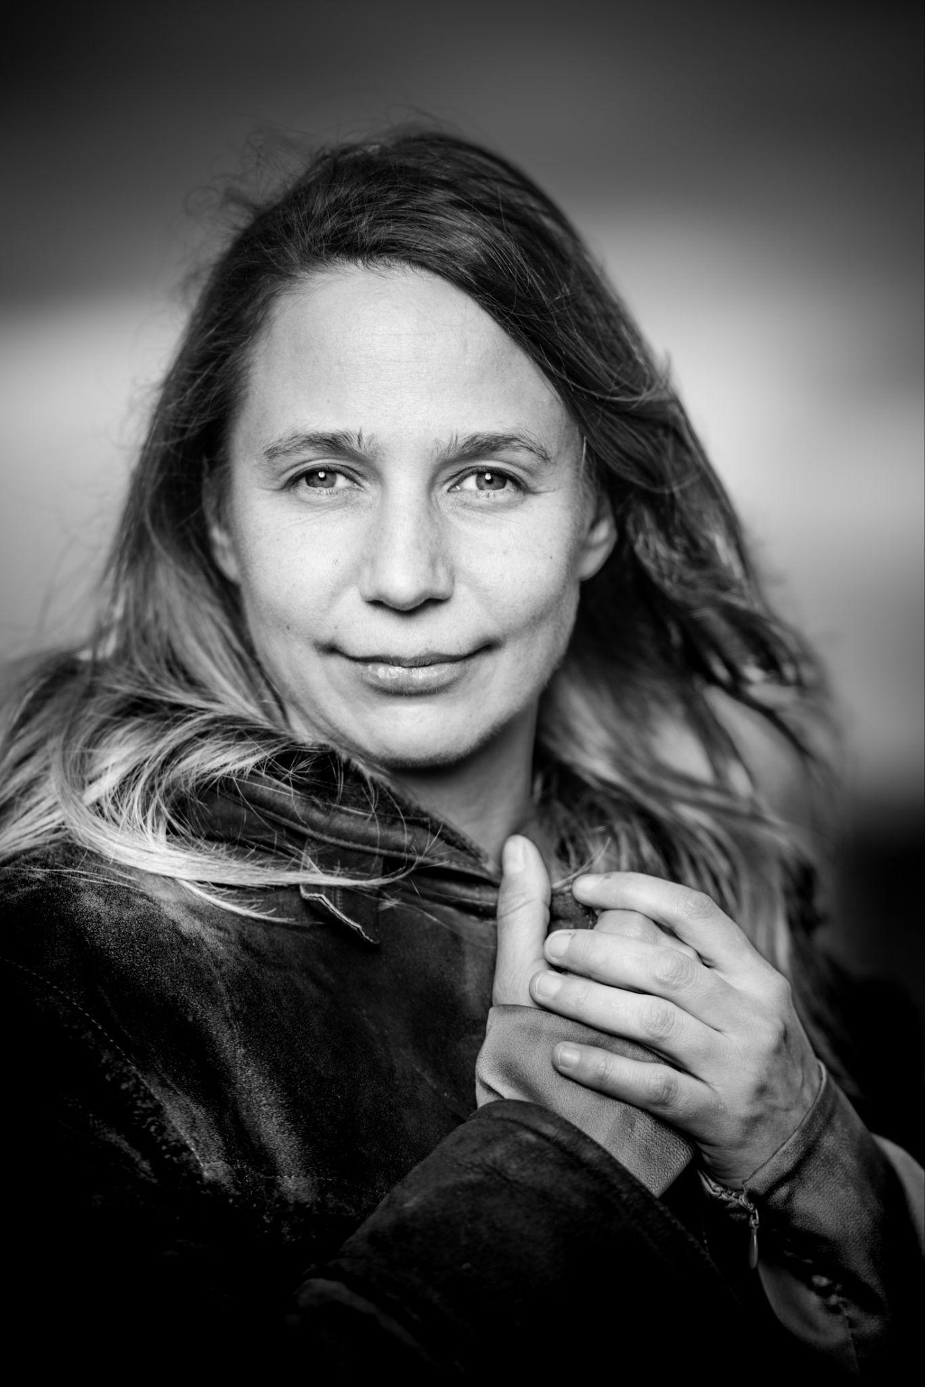 | Kate Moore – City Composer of Amsterdam  Kate Moore is an internationally acclaimed composer who won the Gieskes-Strijbis Podium Prize in 2022 and the Matthijs Vermeulen Prize in 2017 for her composition The Dam. Her works are performed by leading ensembles such as Asko|Schönberg, Cello Octet Amsterdam, Bang on a Can, and the Radio Philharmonic Orchestra. Moore studied at the Australian National University, the Royal Conservatoire in The Hague, and earned her doctorate at the Sydney Conservatorium of Music. She has received prestigious residencies from the MacDowell Colony, Yaddo, and Civitella Ranieri. As composer-in-residence, she has worked at institutions including the Paris Conservatory and the Muziekgebouw. She lives and works in Amsterdam.
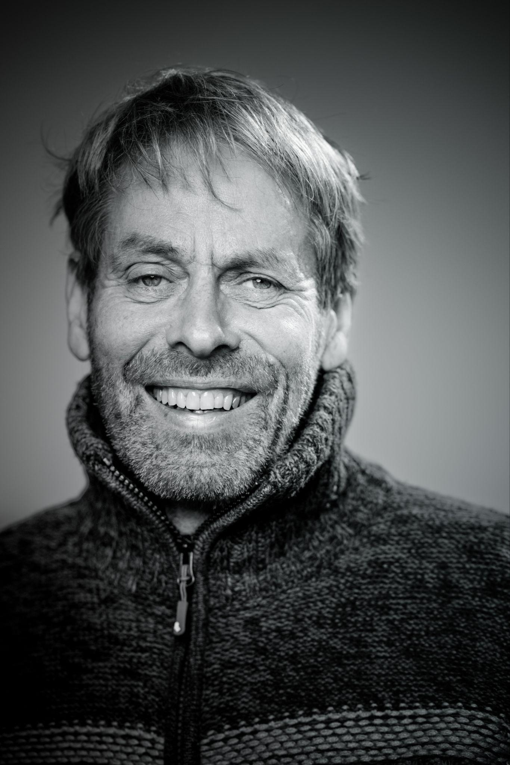 | Andries van Rossem et al. – City Composer of Arnhem  Andries van Rossem studied organ at the Arnhem Conservatory and composition in Rotterdam with Klaas de Vries and Peter-Jan Wagemans. He furthered his studies with Franco Donatoni in Milan and attended masterclasses with composers including Morton Feldman. His work has been performed by esteemed ensembles and orchestras such as the Dutch Ballet Orchestra, Het Gelders Orkest, Radio Chamber Orchestra, Asko|Schönberg, Ensemble Recherche, and the Kronos Quartet. Van Rossem was composer-in-residence at ArtEZ (1992–93), Het Gelders Orkest (1993), and Musis (2016–17). As co-founder of music theatre company De Plaats, he created around twenty productions. He was also a long-time lecturer in contemporary music and music theatre at ArtEZ.
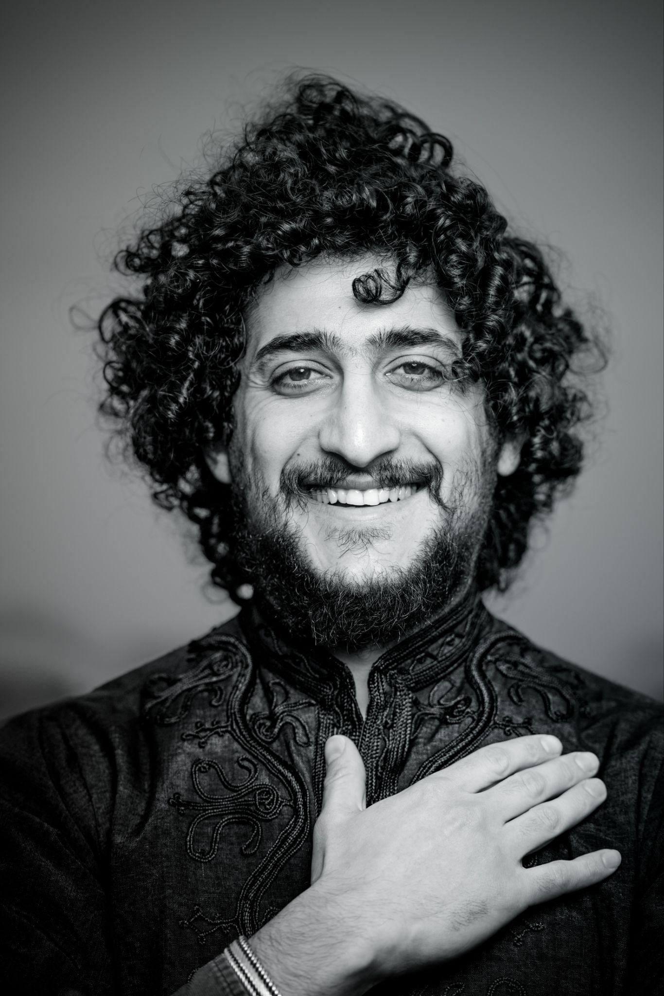 | Nawras Altaky – City Composer of Utrecht  Nawras Altaky is a composer, vocalist, and oud player based in Utrecht. Born in 1995 in the As-Suwayda region of southern Syria, he studied Musician 3.0 at the Utrecht Conservatory. His wide range of experience makes him exceptionally suited for the role of City Composer. He performs with the MaDaBa Quartet, which includes Tony Roe, among others. His compositions have been featured at North Sea Jazz, November Music, Music Meeting, Grachtenfestival, Paradox, and more. Nawras’s music reflects a deep connection to diverse musical cultures, masterfully blending them into contemporary compositions enriched with the beauty of Arabic melodies, the freedom of jazz harmonies, and the strength of classical counterpoint.
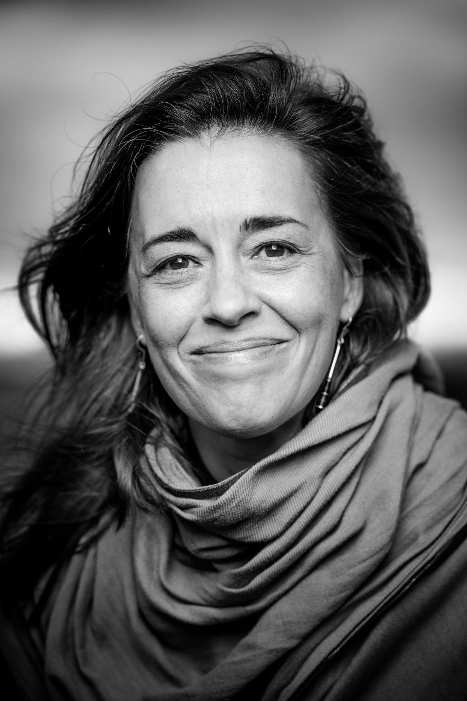 | Saskia Venegas – City Composer of Rotterdam  Saskia Venegas Aernouts is a Spanish-Belgian composer, music theatre creator, and violinist. She lives and works in Rotterdam. Her work explores socio-political themes through interdisciplinary performances in which music takes center stage. Her compositions address unresolved crimes from the Franco era, trauma in the cello cycle Medusa, and the refugee crisis in the symphonic poem At the Aegean Shores. She has collaborated with directors such as Milo Rau and Hassan Khayoon and is the founder and artistic director of Ensemble Oihua. With her project Spain’s Silenced Voices, she brings attention to composers suppressed during the Spanish dictatorship. In 2024–2025, she is part of the Nieuwe Makers program at Music Meeting, receiving coaching from David Harrington (Kronos Quartet), Jen Shyu, and Paola Prestini. A new work of hers will premiere in May, performed by the renowned Kronos Quartet.
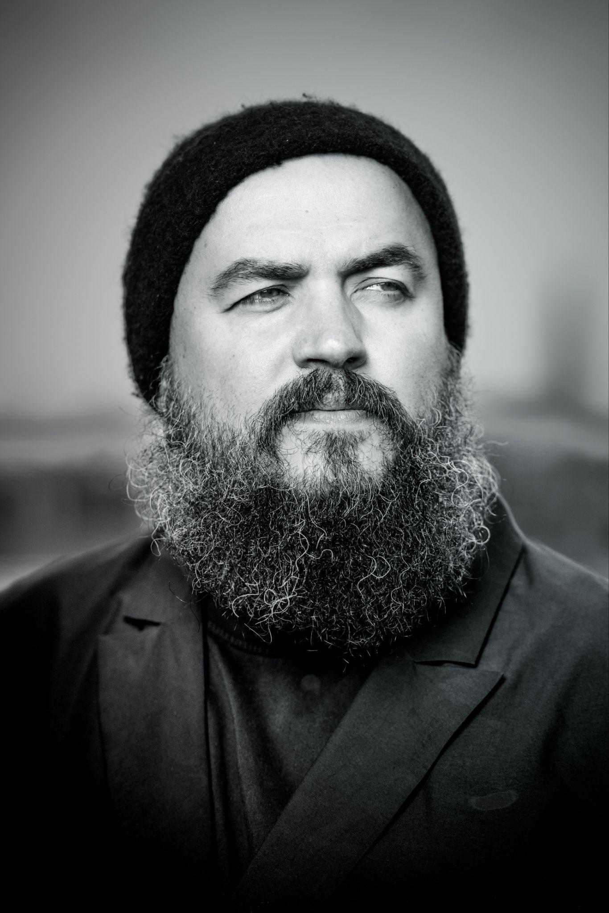 | Maxim Shalygin – City Composer of The Hague  Maxim Shalygin is a versatile artist who is not only a composer but also a conductor, poet, and visual artist. With meticulously crafted scores, he creates vivid musical narratives performed around the world, from the Concertgebouw to Carnegie Hall. His work is interpreted by top ensembles such as the Netherlands Chamber Choir, Asko|Schönberg, and Amsterdam Sinfonietta. Shalygin has a particular affinity for solo works, which he sees as a way to express “the most hidden, intimate, and profound things.” This results in intense compositions like Letters to Anna for solo violin. He is also known for his groundbreaking Similar cycle for identical instruments. In 2025, two major orchestral works will premiere, performed by the Rotterdam Philharmonic Orchestra and the Radio Philharmonic Orchestra.
 | Angela de Weijer aka Miss Millivolt – City Composer of Heerlen  Angela de Weijer is a multidisciplinary artist, composer, and DJ from Eindhoven. Her work centers on rethinking and re-listening to the world. She explores both grand themes—like composing for air raid sirens—and small, conceptual sounds. Artistic research and phenomenology are core to her creative process. Since 2020, she has been one of the three “synthlords” in the experimental ambient-drone-EDM collective Drone Assembly. From 2024 to 2026, she serves as City Composer of Heerlen. Her work has been featured at the Monheim Triennale. She graduated cum laude from Fontys Academy of the Arts and earned a master's degree from the ArtScience department of the Royal Conservatoire in The Hague.
 | Hans Leenders – City Composer of Maastricht  Hans Leenders studied organ in Maastricht, Utrecht, and Brussels with teachers such as Jean Wolfs, Jan Raas, and Jean Boyer, and specialized in French Baroque music. In 1994, he became cantor-organist of the Basilica of Our Lady in Maastricht and professor of organ at the Maastricht Conservatory. He leads Studium Chorale and conducts various choirs. Leenders has appeared as guest conductor with leading choirs and festivals both nationally and internationally. His commitment to contemporary music is evident through numerous premieres. He has made many recordings as an organist and conductor, and his compositions are published by Ascolta. Hans Leenders is a member of the Limburg Composers Foundation and has been appointed City Composer of Maastricht for 2025–2026.
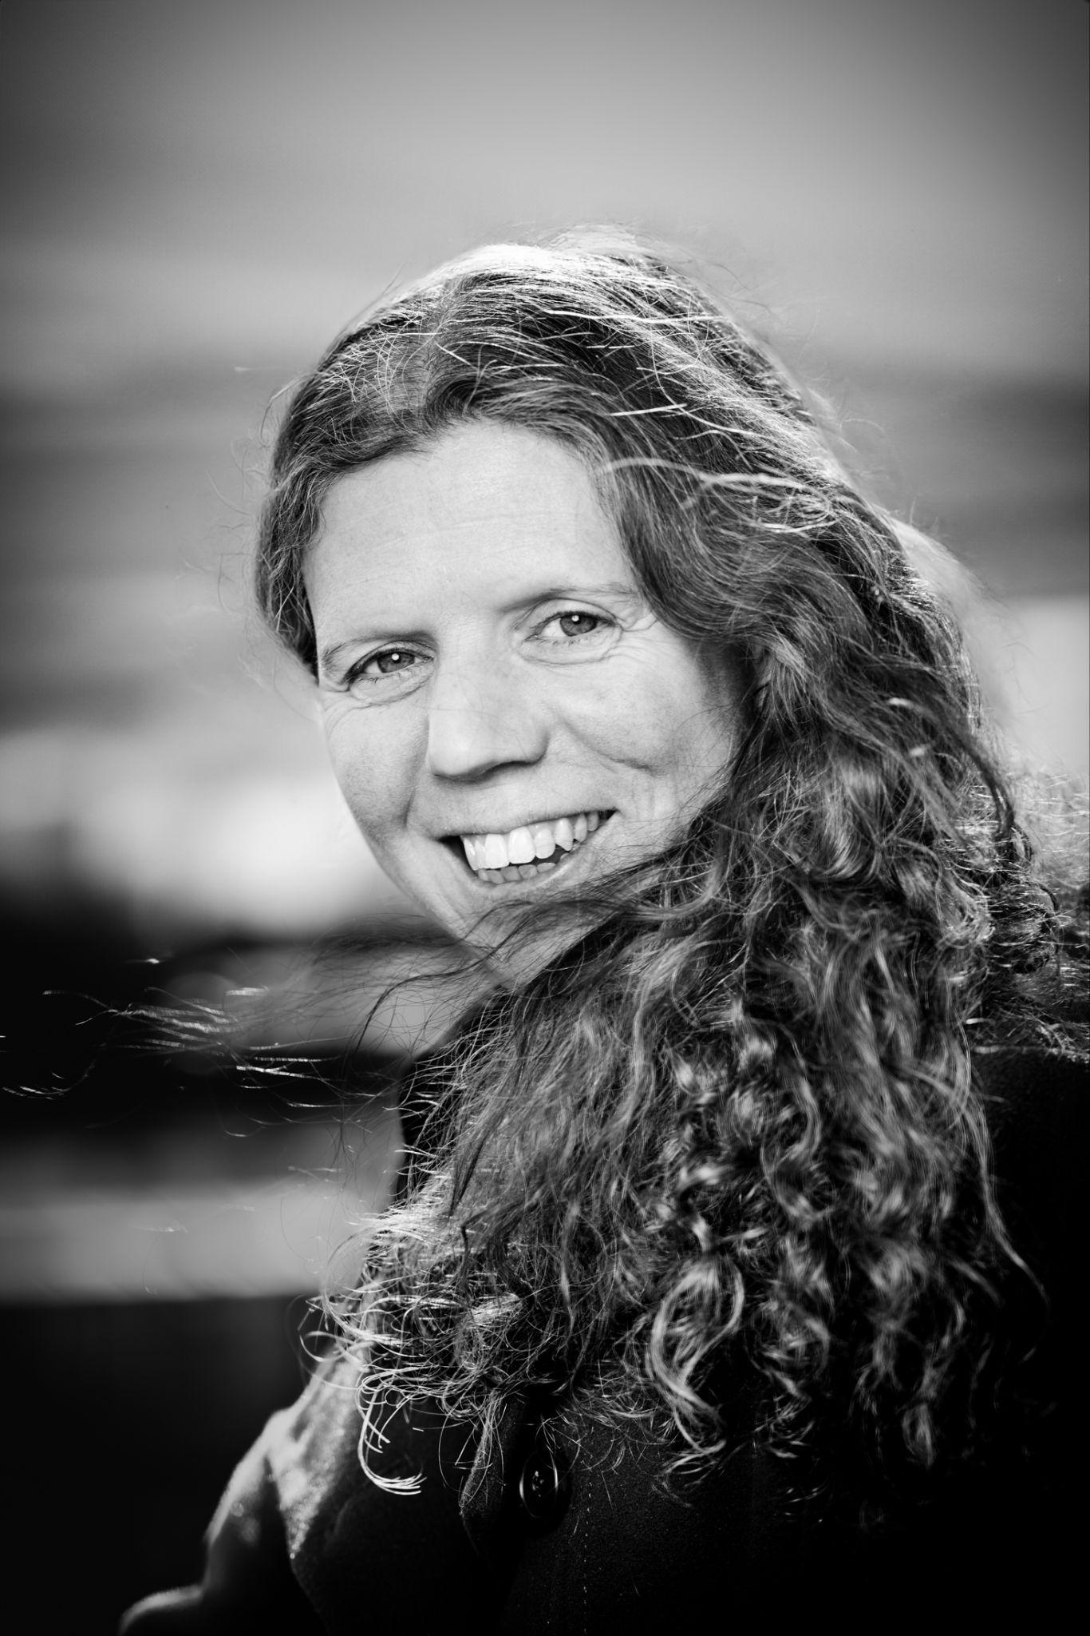 | Nicoline Soeter – City Composer of Tilburg  Nicoline Soeter works as a composer and artistic director of Ensemble VONK (together with soprano Rianne Wilbers), collaborating directly with musicians or co-creating productions with other composers and theatre makers. She has written works for Erik Bosgraaf, Heleen Hulst and An Raskin, Toeac, Tiptoe Company, Ensemble 306, soprano Juliet Fraser & Explore Ensemble, and mezzo-soprano Barbara Kozelj. In 2013, she won the Art and Philosophy Prize awarded by bkkc, Tilburg University, and Avans Universities of Applied Sciences. Her work has been performed at November Music, Transit Festival, Gaudeamus, Grachtenfestival, Huddersfield Contemporary Music Festival, and the Day of Philosophy. As of 21 June 2025, Nicoline Soeter is the City Composer of Tilburg.

