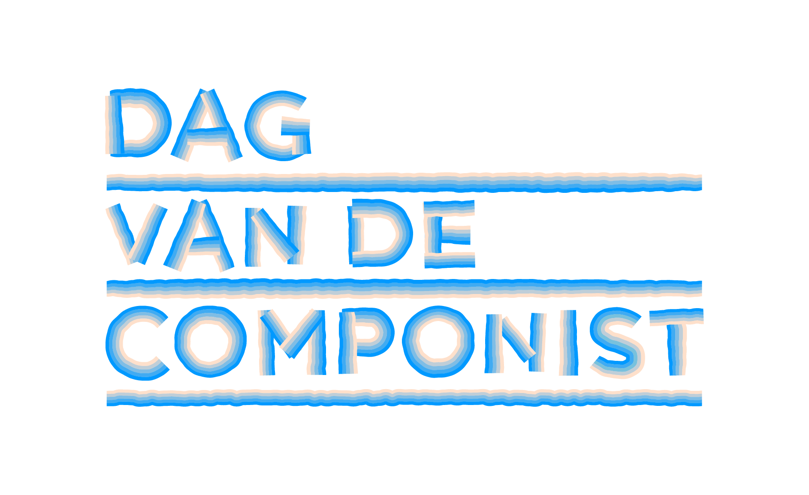
Press release, 12/6/ 2025

Composer’s Day Turns the Netherlands into One Big Music Station on June 21

On and around Saturday, June 21, 2025, the fourth edition of Composer's Day will take place. Composer's Day transforms the Netherlands into one big music station. During this national festival, more than twenty participating cities will put their composers in the spotlight with a variety of activities, such as concerts, workshops, and lectures. City composers will create a new City Song for their city. The public can travel from station to station with the New Music NOW Express. Live performances will take place in the train's carriages and at the stations. Radio station NPO Klassiek and the online music platform newmusicnow.nl will devote plenty of attention to Dutch new music art. Composer's Day is an initiative of New Music NOW and is unique in Europe.

With Composer's Day, the Netherlands celebrates the importance, value, and joy of new music. Composers active here and now in our country deserve to be heard much more often. Therefore, the festival highlights them in all their versatility. They are visibly present and approachable to the public, giving workshops and lectures, curating programs, and offering a "peek into their world." And, of course, their music is heard. Not only in concert halls but also on the streets, at radio and train stations, and on the train itself. With Composer's Day, New Music NOW aims to spark nothing less than a movement because creation and curiosity belong at the heart of musical life.

Composer's Day takes place on and around Saturday, June 21, 2025, and consists of the following elements:

Multi-day program with over 200 composers in more than 20 cities
Numerous music organizations and composer collectives work together as the New Music NOW Network. They will collaborate with composers from their cities and neighborhoods, presenting more than 200 activities across 20+ cities. Participating cities include Amsterdam, Arnhem, Utrecht, Rotterdam, The Hague, Den Bosch, Eindhoven, Tilburg, Heerlen, Maastricht, Almere, Amersfoort, Zwolle, and Groningen. Network partners for Composer's Day include TivoliVredenburg, Concertgebouworkest, Amare, de Doelen, Musis & Stadstheater Arnhem, November Music, Gaudeamus, Intro in Situ Heerlen/Maastricht, De Link Tilburg, Orkest De Ereprijs, and many choirs, ensembles, music associations, conservatories, music schools, artist collectives, publishers, and producers.

New Music NOW Express
The specially chartered bright red music train, the New Music NOW Express, connects the national program and draws a trail of new music across the country. The train stops at five stations: Amsterdam, Arnhem, Utrecht, Rotterdam, The Hague, and returns to Utrecht. On board, there will be plenty of live performances by emerging and renowned composers; the audience sits side by side with musicians and composers in the train carriages.

Newly appointed City Composers and Newly composed City Songs
In the five cities visited by the Express, special City Composers have been appointed. They will compose a new City Song, premiered during the festive Station Concerts, with participation from local choirs, ensembles, conservatories, and other organizations. The City Composers are:
- Kate Moore (Amsterdam)
- Andries van Rossem (Arnhem)
- Saskia Venegas (Rotterdam)
- Maxim Shalygin (The Hague)
- Nawras Altaky (Utrecht)
Additionally, Angela de Weijer (Heerlen), Nicoline Soeter (Tilburg), and Hans Leenders (Maastricht) serve as City Composers for a two-year term.

Station Concerts Along the New Music NOW Express Route
At 05:19 AM, on the longest day of the year, Kate Moore and her Herz Ensemble will open with a sunrise song cycle based on Cantico del Sole at the Marineterrein near Pension Homeland in Amsterdam. This is followed by a communal breakfast and a procession to Amsterdam Central Station for the Station Concert.
09:00 AM – Amsterdam Central Station (Platform 2B):
The City Song "Growing Against the Wind," composed by Kate Moore for the city’s 750th anniversary, will be performed by the VU Chamber Choir. The dynamic Maat Saxophone Quartet is the festival ensemble. Rising star Fuensanta (composer/singer/double bassist) will perform alongside alto saxophonist Ben van Gelder. Martin Fondse and Femi Dawkins will energize the crowd with Your Favorite Music Station. Afterward, the audience can either board the New Music NOW Express or attend other events in the city.
11:30 AM – Arnhem Central Station:
City Composer Andries van Rossem hosts a collective happening with students and alumni of ArtEZ. Composer Tobias Wentink contributes a new City Song, and percussion group performances curated by Dolf de Kinkelder feature prominently, with young talent presented throughout the city.
1:00 – 2:00 PM – Utrecht Central Station (Jaarbeurs side):
A spectacular concert by the 70-member NS Orchestra (Dutch Railways’ in-house ensemble) featuring works by Dutch composers such as Leon Vliex, Eric Swiggers, Emile Stoffels, and Jörgen IJsendorn. Events continue at Museum Speelklok and Sounds Like Juggling under the station’s glass dome.
2:25 – 3:30 PM – Rotterdam Central Station (Rotjekoor Festival):
Belgian-Basque composer Saskia Venegas presents Maasstad, an ode to the city, its harbor, and its people, performed by local choirs, Maat Quartet, and the Basque percussion instrument txalaparta. A musical city route follows, curated by Venegas, including a premiere on June 20 in the Paradijskerk by the Oihua Ensemble.
4:30 PM – The Hague Central Station:
Ukrainian-Dutch composer Maxim Shalygin premieres Burlesque on the Death of a Dictator, performed by the Neo-Fanfare 9x13. The Royal Conservatoire showcases talent at both Amare and the station. The public Trap Theatre at Amare will feature performances by the New European Ensemble and others from 2:00–4:00 PM.
6:20 PM – Utrecht Central Station (glass dome):
City Composer Nawras Altaky presents A City Woven in Music, together with the Young Jazz Society Big Band, Tijn Wybenga, Kika Sprangers, and many Utrecht musicians. This co-production with Gaudeamus brings the day's music full circle.
New Stations in Eindhoven and Maastricht:
Though the Express doesn’t stop there, both cities celebrate the day with their own Station Concerts and local programming.

Closing Concert & 2025 Matthijs Vermeulen Prize Ceremony
8:15 PM – Museum Speelklok, Utrecht
An evening program for the public featuring special guests, composers, top ensembles, and a tribute to the best works of the past year.
Trevor Grahl will receive the Matthijs Vermeulen Prize 2025 for his composition Śpiewnik. Presented by Viktorien van Hulst (Director, Dutch Performing Arts Fund), the jury praised the work’s unique sound world combining memory, identity, and musical innovation—a moving and boundary-breaking piece for organ. The Vermeulen Prize is the Netherlands’ most prestigious composition award, presented biennially.
Program Highlights:
- Ensemble HIIIT performs Ma(n)chine by Zeno van den Broek—a dynamic clash between four percussionists and drum robots with powerful visuals.
- Maat Saxophone Quartet focuses on climate awareness with works by Frieda Gustavs and Ramin Amin Tafreshi.
- Nawras Altaky & friends bring messages of urgency and hope.
- Maya Fridman honors past Vermeulen Prize winners Calliope Tsoupaki and Louis Andriessen with Thin Air and La Voce.
- The spectacular AU-2-MATERIA couture music dress by designer Maartje Dijkstra and composer Beorn Lebenstedt is on display in the church.
The concert is a co-production by New Music NOW, TivoliVredenburg, and the Performing Arts Fund, held at Museum Speelklok (Buurkerk) and recorded for later broadcast.

Favorite Music Stations: Radio NPO Klassiek and New Music NOW TV
Around June 21, Radio NPO Klassiek and New Music NOW TV will focus on Composer's Day. Broadcasters NTR Klassiek, VPRO Vrije Geluiden, and Avrotros will present ten days of composer specials, previews, and live performances on national public radio.

Funding & Partners
Composer's Day 2025 is made possible by various funds and municipalities, including Buma Cultuur, the Cultural Fund, Reinbert de Leeuw Foundation, Dioraphte, Sena Performers Fund, Amsterdam Fund for the Arts, Municipality of Rotterdam, Municipality of Utrecht, Municipality of Arnhem, Berch Heemstede Fund, K.F. Hein Fund, Berch Heemstede Fund, and media partners NTR:Klassiek, VPRO Vrije Geluiden, Avrotros, Concertzender, and many network partners.

For the Composer's Day 2025 program:
https://newmusicnow.nl/dagvandecomponist/

====
Not for publication: contact for press:
Marjolein van Ruiten, PR@marjoleinvanruiten.com, +31 (0)6-200 62 844
Esther Gottschalk, esther@newmusicnow.nl +31 (0)6-27 027 547
Trailer Dag van de Componist – New Music Now
Press photo’s Perskit – New Music Now

